D205 Performance Assessment
DATA ACQUISITION
Instructor: Dr. William Sewell
Student name: Devon E. Johnson
Student ID: 011494484
Email: djo3593@wgu.edu

A. Research question: How does the average cost for multiple internet services vary by state?
- To answer this question, I will need the “monthly_charge” numeric data type column from the original “customer” database, the “state” text data type column from the location table, and the “multiple” varchar data type column from the “services” add-on csv file. The foreign key between “customer” and “location” is the “location_id” integer data type column and the foreign key between “customer” and “services” is “customer_id” text data type column ("Create table," 2024).

B. Create an entity relationship diagram (ERD) for the add-on CSV file and any other tables and columns used to answer the question from part A by evaluating the data contained in the file and identifying the m:n relationships and relational constraints.
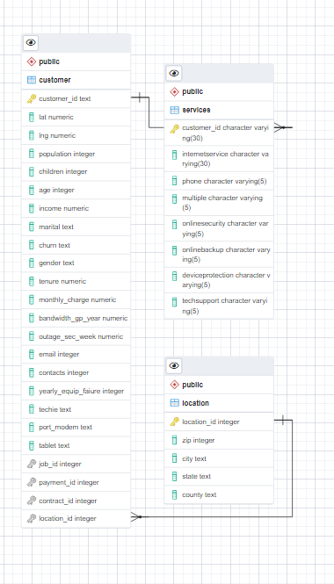
- Write SQL code, in text format, that creates a table based on the ERD and specifies the columns and relevant keys.
CREATE TABLE public."services"
(
customer_id character varying(30) COLLATE pg_catalog."default" NOT NULL,
InternetService character varying(30) COLLATE pg_catalog."default",
Phone character varying(5) COLLATE pg_catalog."default",
Multiple character varying(5) COLLATE pg_catalog."default",
OnlineSecurity character varying(5) COLLATE pg_catalog."default",
OnlineBackup character varying(5) COLLATE pg_catalog."default",
DeviceProtection character varying(5) COLLATE pg_catalog."default",
TechSupport character varying(5) COLLATE pg_catalog."default",
CONSTRAINT "Services_pkey" PRIMARY KEY (customer_id)
)

TABLESPACE pg_default;

ALTER TABLE public."services"
OWNER to postgres;

- Write SQL code, in text format, that loads the data from one of the add-on CSV files into the table created in part B1.
COPY services
FROM 'C:\Users\LabUser\Desktop\services.csv'
DELIMITER ','
CSV HEADER;

C. Write a SQL statement or statements in text format for a query or queries that answer the question from part A. Note: Do not include SQL statements as a screenshot.
SELECT l.state, s.multiple AS multiple_services, AVG(c.monthly_charge) AS average_monthly_charge
FROM customer as c
JOIN location as l ON c.location_id = l.location_id
JOIN services as s on c.customer_id = s.customer_id
WHERE s.multiple = 'Yes'
GROUP BY l.state, s.multiple,
ORDER BY l.state;

state | multiple_services | average_monthly_charge
AK | Yes | 190.5365
AL | Yes | 195.1758
AR | Yes | 185.147
AZ | Yes | 189.0432
CA | Yes | 194.4348
CO | Yes | 191.4331
CT | Yes | 184.1811
DC | Yes | 200.8793
DE | Yes | 187.5189
FL | Yes | 192.1477
GA | Yes | 187.844
HI | Yes | 187.5133
IA | Yes | 193.9346
ID | Yes | 192.524
IL | Yes | 191.2385
IN | Yes | 189.0593
KS | Yes | 194.7672
KY | Yes | 189.8323
LA | Yes | 190.4401
MA | Yes | 187.7087
MD | Yes | 187.6843
ME | Yes | 190.7435
MI | Yes | 191.9183
MN | Yes | 189.8476
MO | Yes | 187.2149
MS | Yes | 189.0265
MT | Yes | 192.7043
NC | Yes | 188.1455
ND | Yes | 184.7619
NE | Yes | 182.8313
NH | Yes | 195.345
NJ | Yes | 183.8999
NM | Yes | 194.9776
NV | Yes | 206.5875
NY | Yes | 191.614
OH | Yes | 189.9366
OK | Yes | 188.8667
OR | Yes | 184.6379
PA | Yes | 186.5692
PR | Yes | 194.4768
RI | Yes | 166.2517
SC | Yes | 196.1196
SD | Yes | 189.3429
TN | Yes | 188.6589
TX | Yes | 192.0584
UT | Yes | 196.9481
VA | Yes | 190.8187
VT | Yes | 190.4025
WA | Yes | 194.9835
WI | Yes | 195.4736
WV | Yes | 192.8794
WY | Yes | 190.434

D. Identify the specific time period for how often the add-on file should be acquired and refreshed in the database for the data to remain relevant to the business and the question from part A.
According to Dimensions, a platform that houses research and publications for data analysts, datasets should be updated at least weekly. However, one should also consider business needs when determining update timelines as major updates may be required on a more on-demand basis (Digital Science, 2022). Conducting regular database review is essential to sustaining and enhancing customer satisfaction, as well as for uncovering business trends (OptimizDBA Team, 2021).

E. Panopto Video Link: D205 Performance Assessment Video_Devon Johnson

Works Cited
Create table. (2024, February 8). PostgreSQL Documentation. https://www.postgresql.org/docs/current/sql-createtable.html
Digital Science. (2022, March 3). How often is the data updated? Dimensions. https://plus.dimensions.ai/support/solutions/articles/23000012985-how-often-is-the-data-updated-
OptimizDBA Team. (2021, July 28). [2021]When should your business think about database updates? OptimizDBA.com. https://optimizdba.com/2021when-should-your-business-think-about-database-updates/

